**ACTIVITIES IN APPLICATION DEVELOPMENT AND EMERGING**

**TECHNOLOGIES (*)**

**SY: 2024 – 2025 SECOND SEMESTER**

**INTRODUCTION TO APPLICATION DEVELOPMENT**

**Activity 1:** Exploring Application Types (Discussion-Based Activity)

Objective: Identify and differentiate web, mobile, and desktop applications.

1. **Web Application: Zoom**

**Purpose:**

- Zoom is a video conferencing platform used for online meetings, webinars, and virtual events. It allows users to conduct face-to-face meetings, share screens, and collaborate remotely.

**Features:**

* HD video and audio conferencing with up to 1,000 participants.
* Screen sharing for presentations or collaboration.
* Breakout rooms for smaller group discussions during meetings.
* Recording meetings for later viewing.
* Virtual backgrounds and filters to customize the appearance during meetings.
* Chat functionality to send messages during meetings.
* Integration with tools like Google Calendar, Slack, and Microsoft Teams.

**Target Users:**

* Businesses, educators, remote teams, and anyone needing virtual meeting capabilities.

**Advantages:**

* Easy to set up and use, even for people who aren’t tech-savvy.
* Offers a free plan with essential features (up to 40-minute meetings with 100 participants).
* Reliable video and audio quality, even for large meetings.
* Customization features such as virtual backgrounds, meeting recordings, and webinar support.

**Limitations:**

* Free plan has time limits on meetings (40-minute limit for group meetings).
* Can experience lag or technical issues depending on the internet connection.
* Security concerns and occasional “Zoom bombing” incidents (although security features have improved).

1. **Mobile Application: WhatsApp**

**Purpose:**

WhatsApp is a messaging mobile application that allows users to send text messages, voice messages, make calls, and share multimedia content such as images, videos, and documents.

**Features:**

* Text messaging, voice messages, and video calls.
* Group chats and broadcast messages.
* End-to-end encryption for secure messaging.
* Sharing of multimedia content, including documents, images, videos, and location.
* Status feature (similar to Instagram Stories) for sharing temporary updates.
* Web version to sync with desktop devices for messaging.

**Target Users:**

* General public for personal communication, businesses for customer service, and groups for organizing events or conversations.

**Advantages:**

* Cross-platform support (works on Android, iOS, and web).
* Secure with end-to-end encryption.
* Simple interface and easy to use.
* Free messaging and calling over the internet, saving on SMS and phone bills.

**Limitations:**

* Limited to messaging and calling functionalities (no support for other forms of collaboration).
* Requires an internet connection for messaging and calling.
* Limited file-sharing size and capabilities compared to professional tools.

1. **Desktop Application: Microsoft Excel**

**Purpose:**

Microsoft Excel is a powerful desktop application for spreadsheet creation, data analysis, and visualization. It’s widely used for tasks such as financial analysis, budgeting, project tracking, and data manipulation.

**Features:**

* Extensive functions for calculations (e.g., SUM, VLOOKUP, IF statements).
* Pivot tables for summarizing and analyzing data.
* Charting and graphing tools to visualize data.
* Macros and automation to simplify repetitive tasks.
* Integration with other Microsoft Office applications (e.g., Word, PowerPoint) and third-party apps.
* Advanced tools for financial modeling, statistical analysis, and forecasting.

**Target Users:**

* Professionals in finance, accounting, data analysis, project management, and anyone working with large datasets.

**Advantages:**

* Full-featured software with advanced analytical and data manipulation capabilities.
* Extensive functionality with customizable features such as formulas, macros, and add-ins.
* Excellent for large datasets and complex calculations.
* Offline functionality after installation (no internet required).

**Limitations:**

* Steep learning curve for beginners, especially when using advanced features like macros and pivot tables.
* Can be costly due to the Microsoft Office subscription model.
* Requires powerful hardware to handle extremely large files.

**General Comparison of Web, Mobile, and Desktop Applications.**

|  |  |  |  |
| --- | --- | --- | --- |
| **Feature/Aspect** | **Web Application: Zoom** | **Mobile Application: WhatsApp** | **Desktop Application: Microsoft Excel** |
| **Purpose** | Video conferencing and virtual meetings. | Messaging, voice calls, multimedia sharing. | Data analysis, spreadsheet management, and reporting. |
| **Target Users** | Businesses, remote teams, educators, and organizations. | General public, small businesses, groups. | Professionals in finance, project management, and data analysis. |
| **Collaboration** | Excellent for virtual collaboration in meetings. | Real-time messaging, group chats, and calls. | Limited collaboration (some integration with Teams and OneDrive). |
| **Platform Dependency** | Browser-based, available on all platforms (Windows, macOS, mobile). | Platform-specific (iOS/Android). | Platform-dependent (Windows/macOS). |
| **Connectivity** | Requires a stable internet connection for optimal video/audio quality. | Requires internet for messaging and calls. | Fully functional offline, but can sync with cloud storage. |
| **Learning Curve** | Very easy to use, intuitive setup and user interface. | Very user-friendly, minimal learning curve. | Steep learning curve for advanced features like formulas and macros. |
| **Data Storage** | Cloud-based for meeting recordings and chat history. | Local device storage, cloud backup optional. | Local storage (can integrate with cloud storage services). |
| **Security** | End-to-end encryption for meetings, secure login. | End-to-end encryption for messaging and calls. | Local security (encryption, password protection). |
| **Offline Functionality** | Offline meetings possible with Zoom's dial-in feature, but video is disabled. | Limited functionality without internet. | Fully functional offline. |
| **Customization** | Customizable virtual backgrounds, webinar settings, and meeting controls. | Highly customizable settings (notifications, themes). | Highly customizable with macros, add-ins, and toolbars. |

Web Application: Zoom is the go-to platform for remote meetings and webinars. It offers an easy-to-use interface, reliable performance, and a range of features to support virtual communication. Its free plan has limitations, but it’s a great tool for teams and organizations looking to conduct remote meetings, classes, or events.

Mobile applications like WhatsApp are ideal for on-the-go communication and social interactions but are limited by the mobile environment (screen size, input limitations).

·

Desktop applications like Microsoft Excel are essential for heavy-duty work involving large datasets and advanced data analysis but are less portable and often require a powerful computer.

·

**ACTIVITY 2. Setting Up a Development Environment (Hands-On-Activity)**

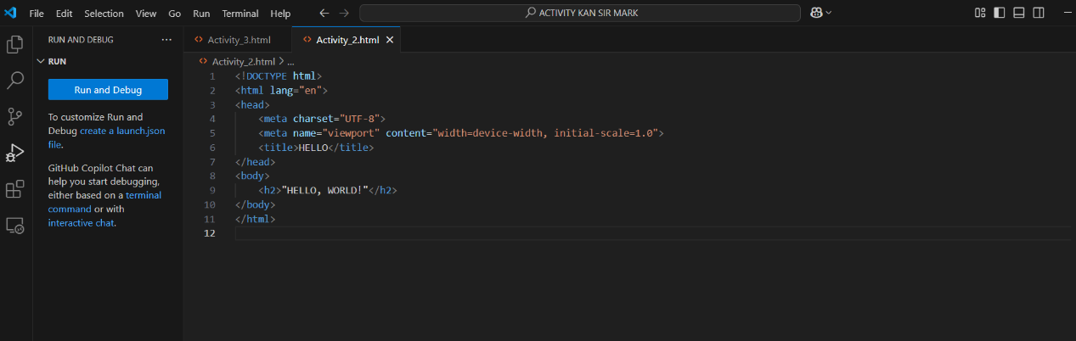

RESULT:

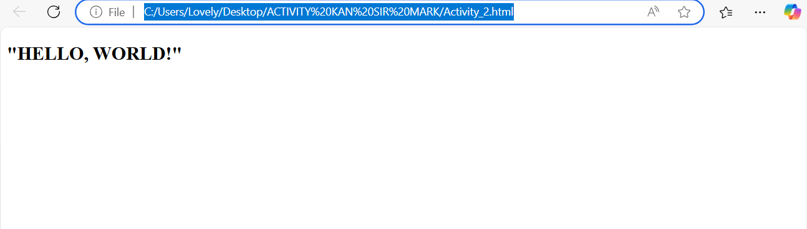

**ACTIVITY 3. Introduction to Programming (Coding Exercise)**

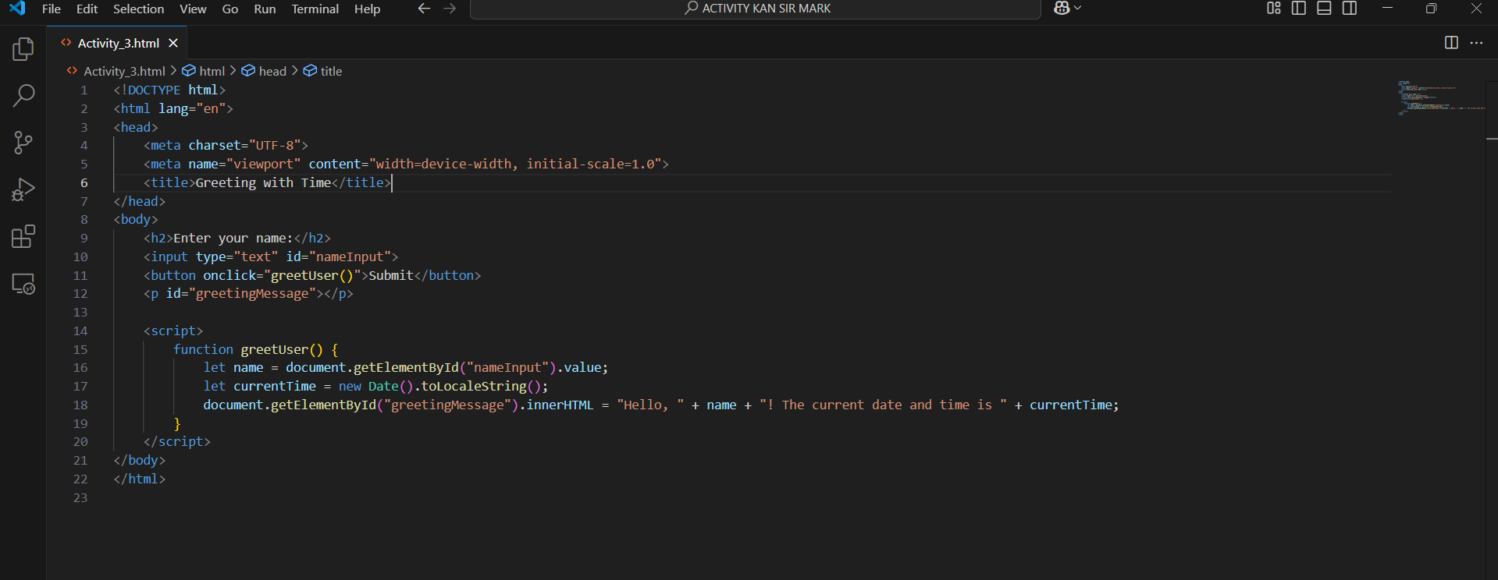

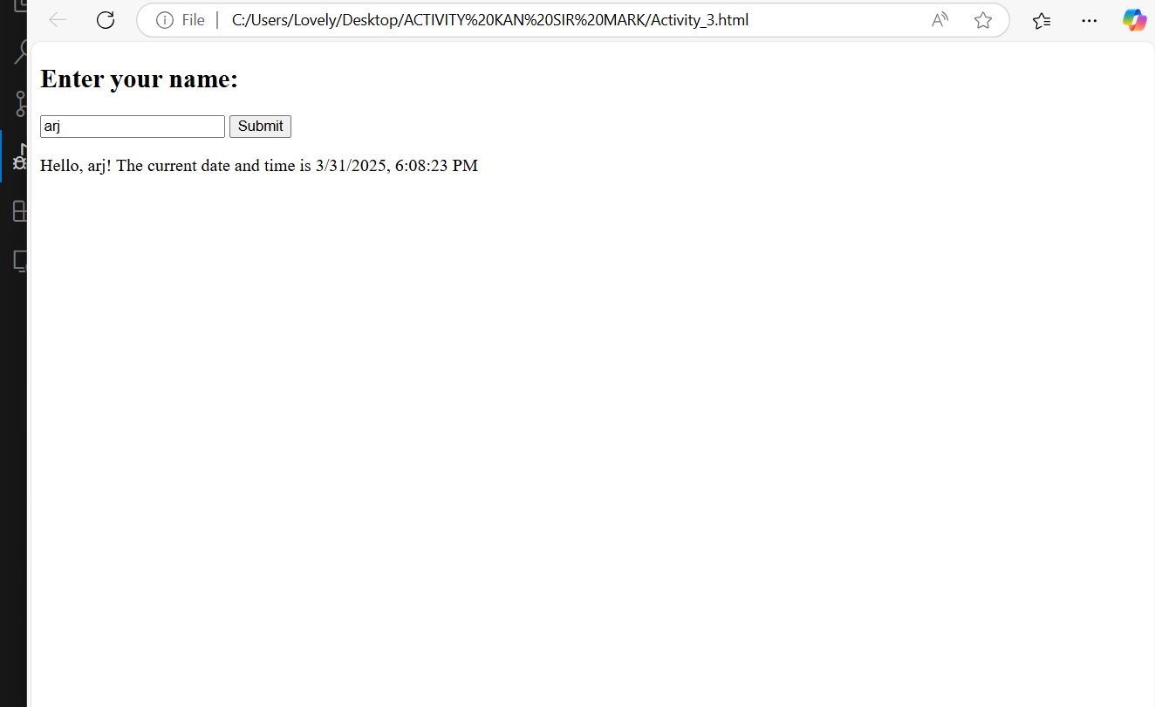RESULT: